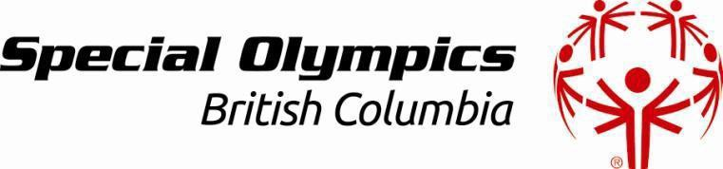 Abbotsford Program Schedule 2021 - 2022

Program | Day of week | Venue | Head Coach |  | Dates
Winter Sport
Bowling 5 Pin | Sunday 6:30 – 8:30pm | Galaxy Bowling | Leslie Bowling | September - April
Bowling 10 Pin | Saturday  10:30 – 12:30pm | Zone Bowling  (Coquitlam) | Evelyn Robinson | October - April
Aquatics (Swimming) | Saturday 4:00 - 5:30pm  Thursday 6:00 – 7:00pm | ARC  MRC  (competitive) | Rita Wakely | September – March  September - June
Curling | TBA | Abbotsford Curling Club | Cheryl Marsh | October – Feb
Speed Skating | Mon & Friday 4:30 – 5:30pm  Mon, Wed & Fri. 5:45 – 6:45pm | ARC | Donna Bilous | September – March
Club Fit | Monday 4:45 – 5:45pm | ARC | Tom Norton | October to March
Figure Skating | Saturday  8:15 - 9:30am | Mission Leisure  Centre | Nicole Ginter | October - March
Powerlifting | Saturday 12:00 – 1:45pm | TBA | Colleen Moore | September - June
Floor Hockey | Wednesday 6:00 – 7:30pm | Ag Rec Building | Bruce Watkins | October - March
Basketball | Monday 6:30 – 8:30pm | WA Fraser | Kara Haveman | October – March
Rhythmic Gym | Wednesday 5:00 – 8:00pm | Emmanuel Mennonite  Church | Nancy Bergen | October to March
Active Start/  FUNdamentals | Wednesday  6:30 – 7:30 | Seniors room  MRC | Amy Gravelle | October to March
Summer Sport
Soccer | Wednesdays 6:00 – 7:30pm | Abby Middle Field | Roshan Gosal |  | April - June
Softball | Monday  5:00 – 8:00pm | Crossley Park | Brian Gaudet |  | April - June
Athletics (Track & Field) | Saturday 10:00 – 12:00pm | Rick Hansen Secondary | Tom Norton |  | April - June
Golf | Saturday  3:00 – 5:00pm | Valley Golf  Centre | Brian Gaudet |  | April – June
Bocce | Sunday  6:00 – 7:30pm | Yale Oval | Leslie Bowling |  | April - June

